

|  |
| --- |
| Capstone Project Document |

**BOOKAHOLIC SOCIAL NETWORK**

Software Requirement Specifications

|  |  |  |
| --- | --- | --- |
| **Bookaholic Social Network** | | |
| **Group Members** | Phạm Thị Huyền | SE03416 |
| Thái Thị Cẩm Vân | SE03409 |
| Vũ Hải Đăng | SE03380 |
| Nguyễn Thị Hải Yến | SE03171 |
| Chu Minh Hải | SE03143 |
| **Supervisor** | Mr. Nguyễn Văn Sang | |
| **Project code** | BSN | |

**- Hanoi, --/2016 -**

# SIGNATURE PAGE

|  |  |  |
| --- | --- | --- |
| AUTHOR: | Phạm Thị Huyền  Project manager | --/--/2016 |
| REVIEWERS: | --------  Team member | --/--/2016 |
| APPROVAL: | Nguyễn Văn Sang  Supervisor | --/--/2016 |

**Record of change**

*A - Added M - Modified D – Deleted

|  |  |  |  |  |  |
| --- | --- | --- | --- | --- | --- |
| Effective Date | Changed Item | A,M,D | Change Description | Reason for Change | Rev. Number |
| --/--/2016 | Create | A | Create | First version | 1.0 |

Table of Contents

SIGNATURE PAGE 2

1. INTRODUCTION 3

1.1. Purpose 3

1.2. Definitions and Acronyms 4

1.3. System Purpose 4

2. OVERALL DESCRIPTION 4

2.1. System overview 4

2.2. Use Case Diagram 4

2.3. Product Features 5

2.3.1. User Characteristics 5

2.3.2. User Documentation 5

2.3.3. Assumption 5

2.4. Entity Relation Model 5

2.4.1. Entity-Relationship Diagram 5

2.4.2. Entity Detail 5

3. FUNCTIONAL SPECIFICATION 5

3.1. Business Rules 5

3.2. Use Cases 5

4. NON-FUNCTIONAL SPECIFICATION 5

4.1. Reliability 5

4.2. Performance Requirements 5

4.2.1. Availability 5

4.2.2. Response time 5

4.2.3. Maintainability 5

4.2.4. Usability 5

4.2.5. Security Requirements 5

4.2.6. Hardware/Software Requirements 5

# INTRODUCTION

## **Purpose**

This document is created as the introduction for project Bookaholic Social Network – our Capstone Project at FPT University. In this document, we provide the describing of general requirement and non-functional requirements. These requirements will assure that the system will correctly and reliably perform its intended functionality. This specification will provide general, as well as specific requirements to be used in the design, testing and validation of the system. It is intended for both stakeholders and the project team of the system.

## **Definitions and Acronyms**

|  |  |  |
| --- | --- | --- |
| **Acronym** | **Definition** | **Note** |
| BSN | Bookaholic Social Network |  |
| SRS | Software Requirements Specifications |  |
| UC | Use Case |  |

Table 1‑1: Definition and Acronyms

## **System purpose**

Nowadays, social network plays an essential role in our lives. Vietnam is the country that has the big Internet user growth and the trend of communication through social network is expanding rapidly, people shares and discuses about everything through social network. However, there is not any social network that is for only Vietnamese people who love reading books. To solve this problem, we create a website where people who loves book can share and discus with others about their favorite books or authors. We believe this project will strengthen Vietnam’s reading culture.

# OVERALL DESCRIPTION

## **System overview**

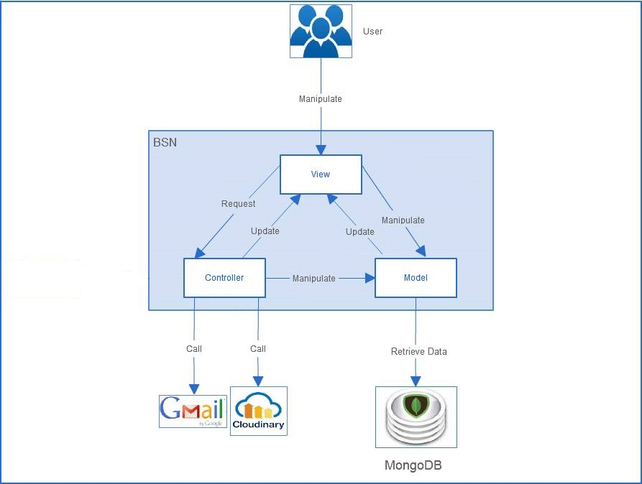

Figure 2‑1: BSN System Overview

## **Use Case Diagram**

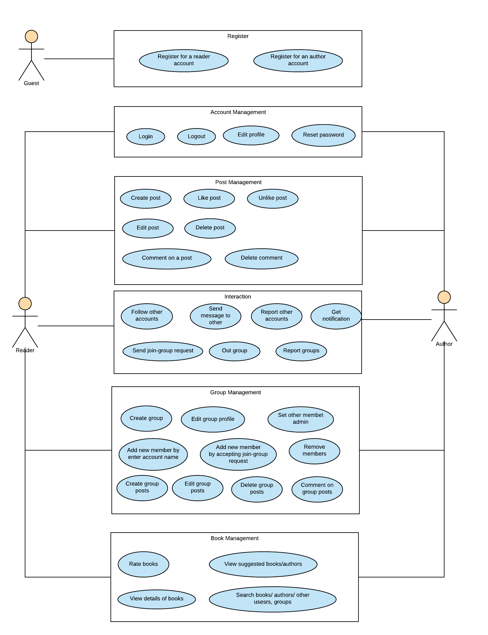

Figure 2‑2: Use Case diagram of Guest, Reader and Author

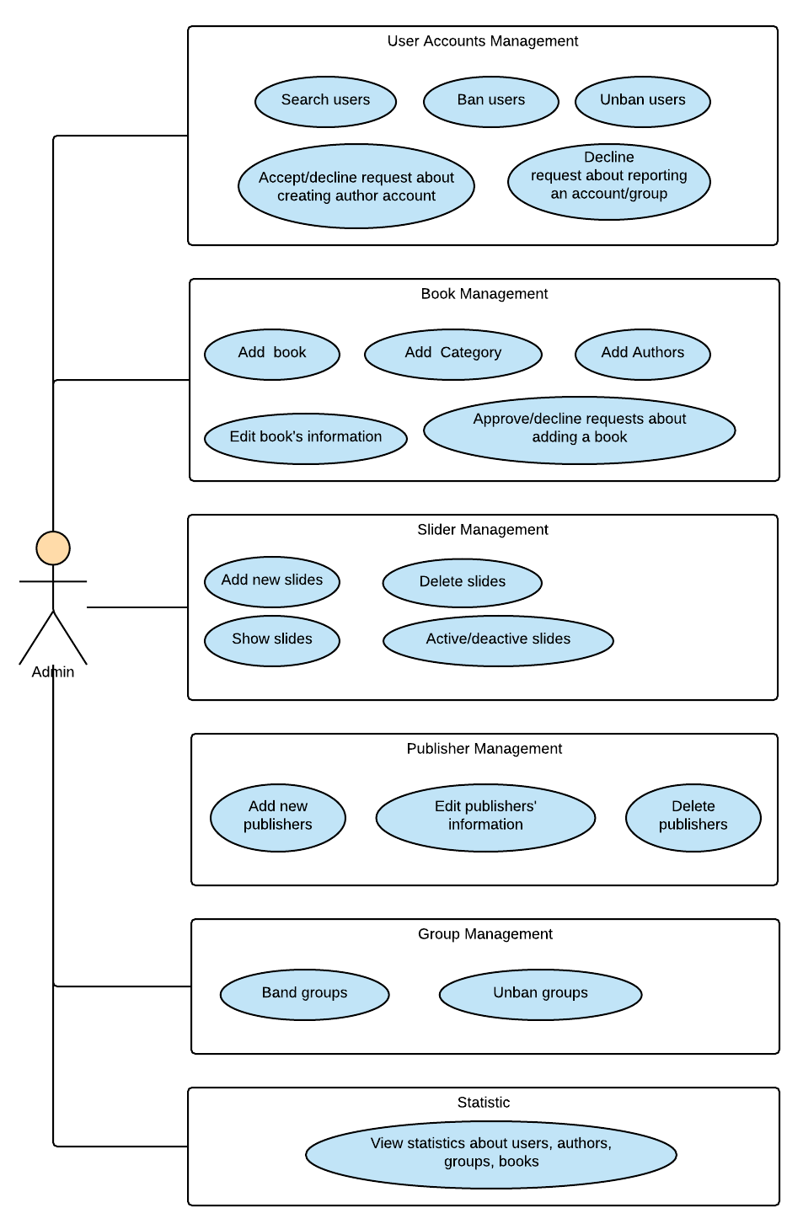

Figure 2‑3: Use Case diagram of Admin

## **Product Features**

|  |  |  |  |
| --- | --- | --- | --- |
| Use Case No. | Group of functions | Functions | Glossary |
| GUEST MODULE | | | |
| UC001 | Register | Register for a normal account | Register for a normal account (reader) |
| UC002 | Register for an author account | Register for an author account: User must upload an image of their identity card and wait for approve from admin of website. |
| READER/AUTHOR MODULE | | | |
| UC003 | Account Management | Login by registered account | Login by registered account |
| UC004 | Logout | Logout |
| UC005 | Edit personal information | Edit personal information includes name, email, address, date of birth. |
| UC006 | Edit avatar and cover photo | Edit avatar and cover photo |
| UC007 | Reset password | Reset password by confirm an auto email. |
| UC008 | Posts Management | Create a post | Create a post to introduce about book(s).  User has to tag book(s) as the topic of that post. |
| UC009 | Edit post | Edit caption and book tags of a created post. |
| UC010 | Delete post | Delete posts |
| UC011 | Like post | Like posts |
| UC012 | Unlike post | Unlike posts |
| UC013 | Comment on a post | Comment on a post |
| UC014 | Delete comment | Delete comments |
| UC015 | Interactions | Follow other account | Follow other account to get their new post on new-feed. |
| UC016 | Send message to other account | Send message to other accounts. |
| UC017 | Report other account | Report other accounts. |
| UC018 | Send join-group request | Send join-group request. After that, users have to wait admin of that group to add them as members. |
| UC019 | Leave a group | Members can leave a group themselves. |
| UC020 | Report a group | Report groups. |
| UC021 | Get Notification | Users get notification when: + Other users like their post + Other users comment on their post  + Other users follow their account |
| UC022 | Groups Management | Create a group | To create a group, users have to tag a book/author as the topic of that group. |
| UC023 | Edit group profile | Edit group profile |
| UC024 | Add new members by enter account name | Add new members by enter account name. |
| UC025 | Add new members by accept join-group request | Users can send a request to group and admin have right to accept them as members or not. |
| UC026 | Set other members admin | Set other members in group as admins. |
| UC027 | Remove members | Admins of a group van remove other members from their group. |
| UC028 | Create group posts | Create group posts: Members do not need to tag books or authors. |
| UC029 | Edit group posts | Edit group posts. |
| UC030 | Delete group posts | Delete group posts. |
| UC031 | Books Management | Rate a book | Rate a book: the highest score is 5 stars. |
| UC032 | View details about a book | View details about a book: image, description, rating and comments of readers about that book. |
| UC033 | Search book/author/other account/group | Search book/author/other account/group |
| UC034 | View suggested books/authors | BSN system suggests books/authors base on the trend of reading: + Book: by access times + Author: by number of followers |
| ADMIN MODULE | | | |
| UC035 | User Accounts Management | Search user | Search user |
| UC036 | Ban user | If an account is reported, admin of page has right to ban that account of decline the reporting request. |
| UC037 | Unban user | Unban user |
| UC038 | Decline request about reporting an account/group | If an account is reported, admin of page has right to ban that account of decline the reporting request. |
| UC039 | Accept/decline request about creating author account | Accept/decline request about creating author account from guests. |
| UC040 | Books Management | Add new book | Add new books. |
| UC041 | Add new Category | Add new Categories. |
| UC042 | Add Authors | Add Authors |
| UC043 | Edit book's information | Edit book's information |
| UC044 | Approve/decline requests about adding a book | Approve/decline requests about adding a book |
| UC045 | Sliders Management | Add new sliders | Add new sliders to introduce about website. |
| UC046 | Delete sliders | Delete sliders. |
| UC047 | Active/de-active a slider | Active/de-active slides. |
| UC048 | Show sliders | Display sliders on the login page. |
| UC049 | Publishers Management | Add new publishers | Add new publishers |
| UC050 | Edit publishers' information | Edit publishers' information |
| UC051 | Delete publisher | Delete publisher |
| UC052 | Groups Management | Band a group | When a group is reported, admin of page can band it. |
| UC053 | Unban a group | Unban a group |
| UC054 | Statistics | View statistic about users | View statistic about users:  + number of old accounts  + number of new accounts |
| View statistic about authors | View statistic about authors: + number of old accounts  + number of new accounts + authors with largest number of followers |
| View statistic about groups | View statistic about groups: + number of old groups  + number of new groups |
| View statistic about books | View statistic about books: + number of old books  + number of new books + the book in trend: base on number of access time |

### **User Characteristics**

### **User Documentation**

### **Assumption**

## **Entity Relation Model**

### **Entity-Relationship Diagram**

### **Entity Detail**

# FUNCTIONAL SPECIFICATION

## **Business Rules**

## **Use Cases**

# NON-FUNCTIONAL SPECIFICATION

## **Reliability**

## **Performance Requirements**

### **Availability**

### **Response time**

### **Maintainability**

### **Usability**

### **Security Requirements**

### **Hardware/Software Requirements**